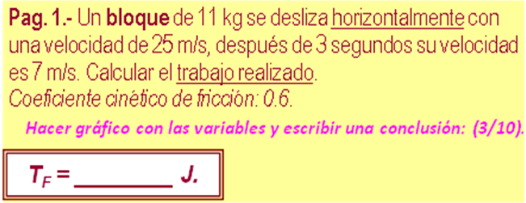

m | 11 | kg
v₁ | 25 | m /s | 3437,5000 | J (Ec₁)
v₂ | 7 | m /s | 269,5000 | J (Ec₂)
t | 3 | s | -6,0000 | m/s² (a)
μ | 0,6 |  | 3104,6400 | J (T/ f)
y | 0 | 100 | 48,0000 | m (d)
x | 100 |  | 0,0000 | m (h)
 |  |  | 0,0000 | J (Eg₂)
 | T= Ec2+T/f+Epg2-Ec1
 |  | T | -63,3600 | J

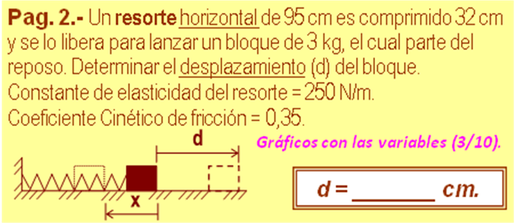

x | 32 | cm | 0,3200 | m
m | 3 | kg | 29,4000 | N (w)
k | 250 | N/m | 12,8000 | J (Epe₁)
μ | 0,35 |  | 3,2928 | J (Tf )
α º | 0 | 0,00
 | 1 | 1
 | Epe1 + Epg1 - Rf*d = 0
 | L = (Epe1 / (w*(μ*cosα-senα))) -x
 |  | L | 1,2439 | m
 | d = (L-x)*100
 |  | d | 92,3926 | cm

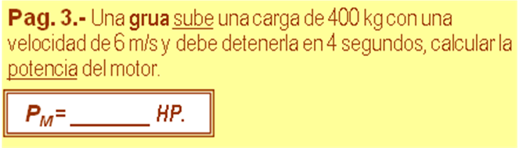

m | 400 | kg | 3920,0000 | N (w)
v₁ | 6 | m/s | 7200,0000 | J (Ec₁)
v₂ | 0 | m/s | 0,0000 | J (Ec₂)
t | 4 | s | -1,5000 | m/s² (a)
h = ( v₂² -v₁² ⁾/ 2 a_{Y} |  |  | 12,0000 | m/s² (h)
 |  |  | 47040,0000 | J (Eg₁)
 | T = (E_{C2} -E_{PG1} -E_{C1})
 |  | T | 39840,0000 | J
 | P = (T / t) *(1 /746)
 |  | P | 13,3512 | HP

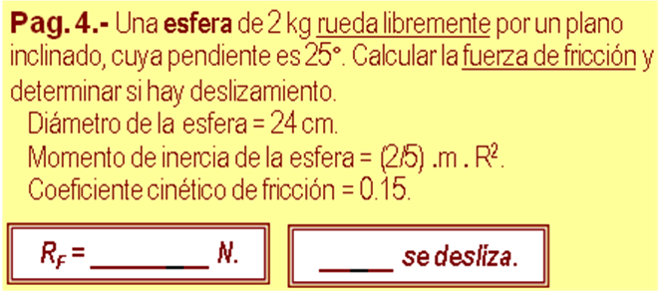

m | 2 | kg
D | no | cm | #¡VALOR! | m
d | 0 | m | 0,0000 | m
μ | 0,15
α º | 25 | 0,47
 | 1,1034 | 1
 | R_{F MAX} = μ *m *g *cosα
 |  | R_{F MAX} | 2,6645 | N
 | R_{F} = (2/7) *m *g *senα
 |  | R_{F} = | 2,3667 | N
 |  | NO | se desliza

