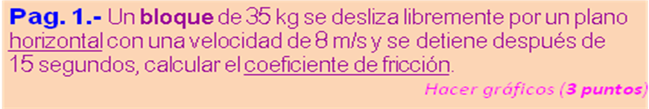


m | 35 | kg |  | 343,0000 | N (Rn)
v₁ | 8 | m /s
v₂ | 0 | m /s
t | 15 | s |  | -0,5333 | m/s² (a)
y | 0 | 100 |  | 60,0000 | m (d)
x | 100 |  |  | 0,0000 | m (h)
 | Tf = m *( g *h - v1^2 /2 )
 |  | Tf | -1120,0000 |  | J
 | μ = -Tf /(d *Rn)
 |  | μ | 0,0544 |  | J

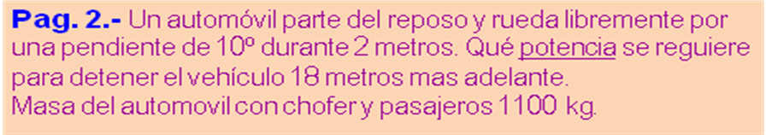


α º | 10 | 0,18 | a ₁₋₂ = g . sen α.
 | 1,0154 | 1 | 1,7018 |  | m/s2 (a ₁₋₂)
v₁ | 0 | m/s | v ₂ = (v ₁^2 +2 *a ₁₋₂ * d ₁₋₂)^2
d ₁₋₂ | 2 | m | 2,6090 | m/s (v ₂)
m | 1100 | kg | 3743,8547 | J (Ec₂)
d ₂₋₃ | 18 | m | 3,1257 | m (h ₂₋₃)
v₃ | 0 | m/s | 33694,6924 | J (Epg₂)
t ₂₋₃ =2*d ₁₋₂ /(v ₂ +v ₃). |  |  | 13,7983 | s (t ₂₋₃)
 | P_{F} = (1/746)*(Epg₂ +Ec₂ )/t ₂₋₃
 |  | P_{F} | 3,6371 | HP

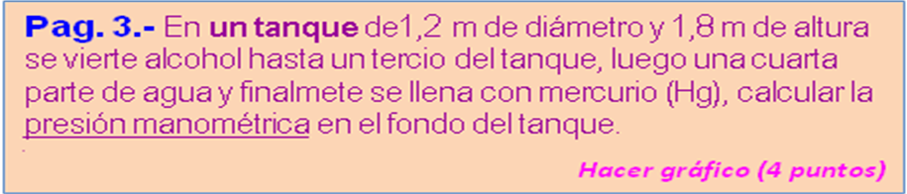
P_{ATM} = | 101325 | Pa
ρ_{1 (Hg) =} | 13600 | kg /m³
ρ_{2 (Agua) =} | 1000 | kg /m³
ρ_{3 (Alcohol) =} | 790 | kg /m³



H | 1,8 | m
y ₃ | 0,3333 | m |  | 0,6000 | m (h3)
y ₂ | 0,25 | m |  | 0,4500 | m (h2)
y ₁ | 0,4167 | m |  | 0,7500 | m (h1)
 |  |  |  | 4645,2000 | Pa (P3)
 |  |  |  | 4410,0000 | Pa (P2)
 |  |  |  | 99960,0000 | Pa (P1)
 |  | P = (P1 + P2 + P3) /1000
 |  | P | 109,0152 |  | kPa

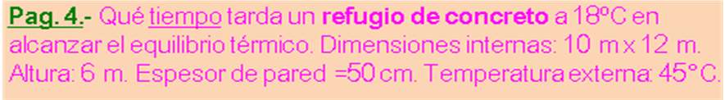
c _{AIRE =} | 0,1700 | cal /gr-ºC
k _{CONCRETO =} | 0,0040 | cal/ cm-s-ºC
ρ _{AIRE =} | 0,0013 | gr /cm³
ρ _{CONCRETO =} | 4,30 | gr /cm³



t _{INT} |  | 18,0 |  | ºC | 18,0 | ºC
t _{EXT} |  | 45,0 |  | ºC | 45,0 | ºC
x |  | 10 |  | m
y |  | 12 |  | m | 3.840.000,0 | cm² (A)
h |  | 6 |  | m | 720.000.000,0 | cm³ (Vol)
esp |  | 50,0 |  | cm | 936.000,0 | gr (m)
Δ_{Q} = m *c_{AIRE}*abs( t _{EXT} -t _{INT}))
 |  |  | Δ _{Q} |  | 4.296.240 | cal
 | t = Δ_{Q}*Esp /(A *k *(abs(t _{EXT)} + abs(t _{INT)})
 |  |  | t |  | 518,0 |  | s
