APÉNDICE A

TABLA DE RECOLECCIÓN DE DATOS

|  |  |  |  |  |  |  |  |  |  |  |  |  |  |  |  |  |  |  |  |  |  |
| --- | --- | --- | --- | --- | --- | --- | --- | --- | --- | --- | --- | --- | --- | --- | --- | --- | --- | --- | --- | --- | --- |
| **Semana #** | |  |  |  |  |  |  |  |  |  |  |  |  |  |  |  |  |  |  |  |  |
| **PREAVISO** | | | | | **SEVERIDAD** | | | | | | | | | | | | | | | | |
| **Pl #** | **EF** | **H2** | **H3** | **H4** | **1** | **2** | **3** | **4** | **5** | **6** | **7** | **8** | **9** | **10** | **11** | **12** | **13** | **14** | **15** | **16** | **TH** |
| **1** | 13.6 | -1 | -2 | -2 | 0 | 0 | 0 | 0 | 0 | 0 | 0 | 0 | 1 |  |  |  |  |  |  |  | 9 |
| **2** | 15.2 | 0 | 1 | -1 | 0 | 0 | 0 | 0 | 0 | 0 | c | 0 | c | 2 |  |  |  |  |  |  | 10 |
| **3** | 14.8 | -1 | -2 | 2 | 0 | 0 | 0 | 0 | 0 | 0 | 1 | 1 | 2 |  |  |  |  |  |  |  | 9 |
| **4** | 12.8 | -1 | -2 | -2 | 0 | 0 | 0 | 0 | 0 | 0 | 0 | 0 | 0 |  |  |  |  |  |  |  | 9 |
| **5** | 12.4 | -1 | 1 | -2 | 0 | 0 | 0 | 0 | 0 | 0 | 0 | 1 | 1 |  |  |  |  |  |  |  | 9 |
| **6** | 15.8 | 0 | 1 | 2 | 0 | 0 | 0 | 0 | 0 | 0 | 0 | 1 | 0 | 2 | 1 |  |  |  |  |  | 11 |
| **7** | 15.2 | 0 | -1 | -1 | 0 | 0 | 0 | 0 | 0 | 0 | 0 | 0 | 0 | 1 | 2 |  |  |  |  |  | 11 |
| **8** | 14.2 | 0 | -1 | -1 | 0 | 0 | 0 | 0 | 0 | 0 | 0 | 0 | 0 | 1 |  |  |  |  |  |  | 10 |
| **9** | 14.8 | -1 | -1 | -2 | 0 | 0 | 0 | 0 | 0 | 0 | 0 | 0 | 0 | 1 | 3 |  |  |  |  |  | 11 |
| **10** | 13.6 | -1 | -1 | 1 | 0 | 0 | 0 | 0 | 0 | 0 | 0 | 0 | 1 |  |  |  |  |  |  |  | 9 |
| **11** | 12.2 | -1 | -1 | -2 | 0 | 0 | 0 | 0 | 0 | 0 | 0 | 1 |  |  |  |  |  |  |  |  | 8 |
| **12** | 12.2 | 0 | 0 | -2 | 0 | 0 | 0 | 0 | 0 | 0 | 0 | 0 | 1 | 1 |  |  |  |  |  |  | 10 |
| **13** | 14.2 | 0 | -2 | -2 | 0 | 0 | 0 | 0 | 0 | 0 | 0 | 0 | 0 | 0 | 1 | 1 |  |  |  |  | 12 |
| **14** | 15.6 | -1 | 1 | 2 | 0 | 0 | 0 | 0 | 0 | 0 | 1 | 0 | 1 | 0 |  |  |  |  |  |  | 10 |
| **15** | 12.8 | -1 | 1 | 2 | 0 | 0 | 0 | 0 | 0 | 0 | 0 | 0 | 1 | 1 |  |  |  |  |  |  | 10 |
| **16** | 13.8 | 1 | -2 | -3 | 0 | 0 | 0 | 0 | 0 | 0 | 0 | 0 | 0 | 1 |  |  |  |  |  |  | 10 |
| **17** | 12.6 | -1 | -2 | -2 | 0 | 0 | 0 | 0 | 0 | 0 | 0 | 1 | 1 | 2 |  |  |  |  |  |  | 10 |
| **18** | 12.2 | -1 | -2 | 2 | 0 | 0 | 0 | 0 | 0 | 0 | 0 | 1 | 2 |  |  |  |  |  |  |  | 9 |
| **19** | 13.2 | 0 | 1 | 2 | 0 | 0 | 0 | 0 | 0 | 0 | 0 | 1 | c | 2 |  |  |  |  |  |  | 10 |
| **20** | 13.4 | 0 | 0 | -2 | 0 | 0 | 0 | 0 | 0 | 0 | 0 | 0 | c | 1 |  |  |  |  |  |  | 10 |
| **-** | 13.6 | -1 | -2 | 2 | 0 | 0 | 0 | 0 | 0 | 0 | 0 | 0 | 2 |  |  |  |  |  |  |  | 9 |
| **-** | 12.2 | 0 | 1 | -2 | 0 | 0 | 0 | 0 | 0 | 0 | 0 | 0 | 1 |  |  |  |  |  |  |  | 9 |
| **-** | 12.2 | 0 | 1 | 2 | 0 | 0 | 0 | 0 | 0 | 0 | 2 | 1 |  |  |  |  |  |  |  |  | 8 |
| **-** | 13.2 | 0 | 1 | 2 | 0 | 0 | 0 | 0 | 0 | 0 | 0 | 1 |  |  |  |  |  |  |  |  | 8 |
| **-** | 12.8 | -1 | 2 | -3 | 0 | 0 | 0 | 0 | 0 | 0 | 1 | 1 |  |  |  |  |  |  |  |  | 8 |
| **-** | 13 | 0 | -2 | -2 | 0 | 0 | 0 | 0 | 0 | 0 | 1 | 1 |  |  |  |  |  |  |  |  | 8 |
| **-** | 13.8 | 0 | -2 | -3 | 0 | 0 | 0 | 0 | 0 | 0 | 0 |  |  |  |  |  |  |  |  |  | 7 |
| **-** | 12.8 | -1 | 1 | 2 | 0 | 0 | 0 | 0 | 0 | 0 | 1 | 2 |  |  |  |  |  |  |  |  | 8 |
| **-** | 14.2 | -1 | 1 | 2 | 0 | 0 | 0 | 0 | 0 | 1 | 2 | 3 |  |  |  |  |  |  |  |  | 8 |
| **-** | 12.4 | -1 | -2 | -3 | 0 | 0 | 0 | 0 | 0 | 1 | 1 |  |  |  |  |  |  |  |  |  | 7 |
| **-** | 12.4 | -1 | 2 | 3 | 0 | 0 | 0 | 0 | 0 | 0 | 1 | 1 |  |  |  |  |  |  |  |  | 8 |
| **-** | 12.4 | 1 | -2 | 2 | 0 | 0 | 0 | 0 | 0 | 0 | 1 | 1 |  |  |  |  |  |  |  |  | 8 |
| **-** | 11.2 | -1 | 1 | -3 | 0 | 0 | 0 | 0 | 1 | 1 | 1 |  |  |  |  |  |  |  |  |  | 7 |
| **-** | 12 | 0 | -2 | -2 | 0 | 0 | 0 | 0 | 0 | 1 | 2 | 3 |  |  |  |  |  |  |  |  | 8 |
| **100** | 13.4 | -1 | 2 | 2 | 0 | 0 | 0 | 0 | 0 | 0 | 0 | 1 | 2 |  |  |  |  |  |  |  | 9 |
| **101** | 12.2 | -1 | -2 | 2 | 0 | 0 | 0 | 0 | 0 | 0 | 1 |  |  |  |  |  |  |  |  |  | 7 |
| **102** | 13.2 | -1 | 1 | 2 | 0 | 0 | 0 | 0 | 0 | 0 | 1 | 1 | 1 |  |  |  |  |  |  |  | 9 |
| **103** | 12.2 | -1 | 2 | 3 | 0 | 0 | 0 | 0 | 0 | 1 | 2 |  |  |  |  |  |  |  |  |  | 7 |
| **104** | 11 | 0 | -2 | 2 | 0 | 0 | 0 | 0 | 0 | 0 | 2 | 2 |  |  |  |  |  |  |  |  | 8 |
| **105** | 12.6 | 0 | -2 | 2 | 0 | 0 | 0 | 0 | 0 | 0 | 1 |  |  |  |  |  |  |  |  |  | 7 |

APÉNDICE B

ANÁLISIS UNIVARIADO PARA LAS VARIABLES ÍNDICE DE INFECCIÓN

|  |  |  |  |  |  |  |  |  |  |  |  |  |  |
| --- | --- | --- | --- | --- | --- | --- | --- | --- | --- | --- | --- | --- | --- |
|  |  | **IND1** | **IND2** | **IND3** | **IND4** | **IND5** | **IND6** | **IND7** | **IND8** | **IND9** | **IND10** | **IND11** | **IND12** |
| **Mínimo** |  | 0 | 0 | 0 | 0 | 0 | 0 | 0 | 0 | 0 | 0 | 0 | 0 |
| **Máximo** |  | 14 | 18 | 17.78 | 20 | 17.78 | 27.27 | 17.14 | 21.82 | 21.82 | 16 | 20 | 13.33 |
| **Media** |  | 4.17 | 4.48 | 4.44 | 5.10 | 5.60 | 7.57 | 5.07 | 5.97 | 7.61 | 5.49 | 6.76 | 5.19 |
| **Mediana** |  | 2.86 | 2.5 | 2.86 | 4 | 4.44 | 5 | 4 | 5 | 6.67 | 4.44 | 6 | 4.44 |
| **Moda** |  | 0 | 0 | 0 | 0 | 0 | 0 | 2 | 0 | 4.44 | 4.44 | 2.22 | 4 |
| **Desv. Estándar** |  | 3.73 | 4.09 | 4.24 | 4.78 | 4.28 | 7.23 | 3.79 | 4.31 | 5.02 | 3.47 | 4.54 | 3.07 |
| **Varianza** |  | 13.88 | 16.69 | 17.95 | 22.82 | 18.34 | 52.28 | 14.39 | 18.57 | 25.20 | 12.06 | 20.63 | 9.41 |
| **Sesgo** |  | 0.63 | 0.84 | 0.88 | 0.81 | 0.87 | 1.39 | 1.29 | 1.02 | 0.89 | 0.58 | 0.94 | 0.73 |
| **Kurtosis** |  | -0.44 | 0.29 | 0.28 | -0.09 | 0.26 | 1.25 | 1.49 | 1.11 | 0.16 | 0.06 | 0.61 | 0.28 |
| **CV** |  | 0.89 | 0.91 | 0.95 | 0.94 | 0.76 | 0.96 | 0.75 | 0.72 | 0.66 | 0.63 | 0.67 | 0.59 |
| **Rango** |  | 14 | 18 | 17.78 | 20 | 17.78 | 27.27 | 17.14 | 21.82 | 21.82 | 16 | 20 | 13.33 |
| **No. Observaciones** |  | 105 | 105 | 105 | 105 | 105 | 105 | 105 | 105 | 105 | 105 | 105 | 105 |
| **Cuartiles** | 25 | 0 | 0 | 0 | 0 | 2.22 | 2.22 | 2.22 | 2.68 | 4 | 3.095 | 2.68 | 2.5 |
|  | 50 | 2.86 | 2.5 | 2.86 | 4 | 4.44 | 5 | 4 | 5 | 6.67 | 4.44 | 6 | 4.44 |
|  | 75 | 6.67 | 7.5 | 7.085 | 8.165 | 8 | 10.455 | 7.27 | 8 | 10.385 | 7.5 | 9.545 | 6.67 |

APÉNDICE C

ANÁLISIS UNIVARIADO PARA LAS VARIABLES TIPO DE SUELO

|  |  |  |  |
| --- | --- | --- | --- |
|  |  | **Arena** | **Arcilla** |
| **Mínimo** |  | 26 | 10 |
| **Máximo** |  | 72 | 26 |
| **Media** |  | 45.9 | 17.62 |
| **Mediana** |  | 46 | 18 |
| **Moda** |  | 26 | 16 |
| **Desv. Estándar** |  | 11.26 | 3.54 |
| **Varianza** |  | 126.72 | 12.55 |
| **Sesgo** |  | 0.22 | 0.19 |
| **Kurtosis** |  | -0.17 | 0.12 |
| **CV** |  | 0.25 | 0.2 |
| **Rango** |  | 46 | 16 |
| **No. Observaciones** |  | 105 | 105 |
| **Cuartiles** | 25 | 38 | 16 |
|  | 50 | 46 | 18 |
|  | 75 | 56 | 20 |

APÉNDICE D

GRÁFICO DE HISTOGRAMAS PARA LAS VARIABLES

ÍNDICE DE INFECCIÓN

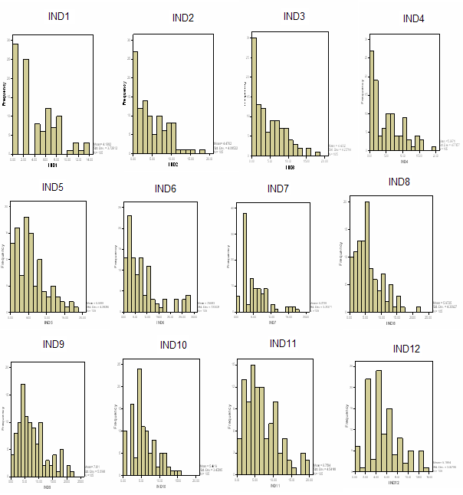

APÉNDICE E

GRÁFICO DE HISTOGRAMAS PARA LAS VARIABLES

TIPO DE SUELO

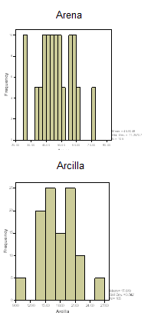

APÉNDICE F

DIAGRAMA DE CAJAS PARA LAS VARIABLES ÍNDICE DE INFECCIÓN



DIAGRAMA DE CAJAS PARA LAS VARIABLES TIPO DE SUELO

