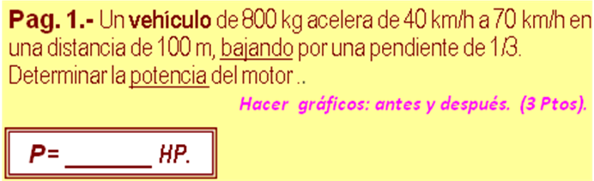

m | 800 | kg | 7840 | N (w)
v₁ | 40 | km/h | 49382,7160 | J (Ec)
v₂ | 70 | km/h | 151234,5679 | J (EC)
d | 100 | m | -31,6227766 | m (h)
tg α | -0,33 | -0,3218 | -247922,5686 | J (Eg₁)
 | T =E_{C2} +E_{PG2} - E_{C1}
 |  | T | -146070,7167 | J
 | t = 2d / (v₂ + v₁ )
 |  | t | 6,545454545 | s
 |  | P | -29,9147 | HP

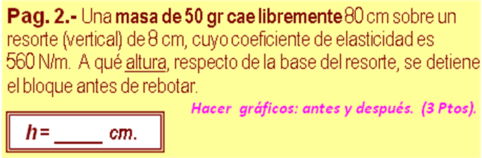

m | 50 | gr | 0,0500 | kg
H | 80 | cm | 0,8000 | m
Lo | 8 | cm | 0,0800 | m
k | 560 | N /m | 560,0000 | N/m
 | [k] h² +[2m.g -2.k .L] h + [k.L^² – 2.m.g(H+Lo)] = 0
 |  |  | 560,0000 | N/m (a)
 |  |  | -88,6200 | N (b)
 |  |  | 2,7216 | Nm (c)
 | h =(-b±(b^2-4*a*c)^0,5)/(2*a)
 | No | h1 | 11,6552 | cm
 | Si | h2 | 4,1698 | cm

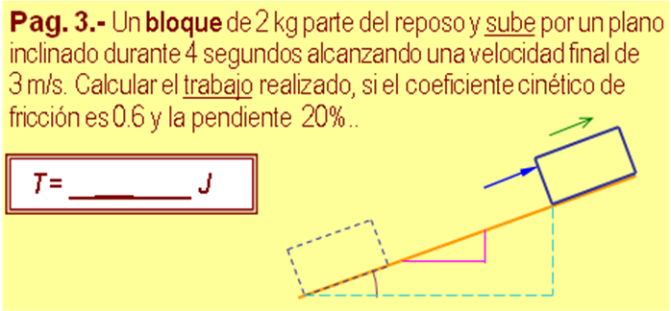

m | 2 | kg | T =E_{C2} +T/μ -E_{PG1} -E_{C1}
v₁ | 0 | m /s | 0,0000 | J (Ec₁)
t | 4 | s | 9,0000 | J (Ec₂)
v₂ | 3 | m /s | 0,7500 | m/s² (a)
μ | 0,6 |  | 69,1898 | J (T/ f)
y | 20 | 101,98 | 6,0000 | m (d)
x | 100 |  | 1,1767 | m (h)
 |  |  | 23,0633 | J (Eg₂)
 | T= Ec2+T/f+Epg2-Ec1
 |  | T | 101,2530 | J

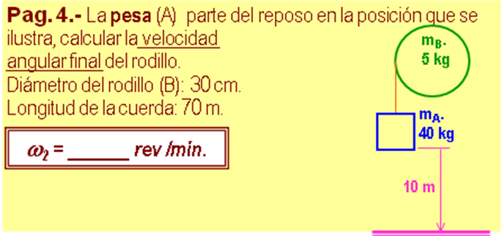

m_{A} | 40 | kg
m_{B} | 5 | kg
h | 10 | m
D | 0,3 | m | 0,1500 | m (R)
 | v₂² = ( 2 ,m_{A} .g .h / ( m_{A} + m_{B} /2 ))^0,5
 |  | v₂ | 13,5820 | m/s
 | ω₂ = (v₂ /R )*(60/(2*pi()))
 |  | ω₂ | 864,6567 | r.p.m.

