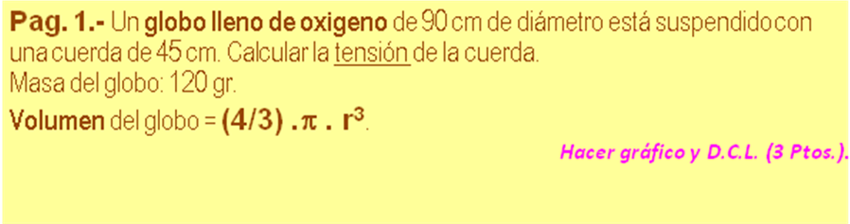
P_{ATM} = | 101325 | Pa
ρ _{OXIGENO =} | 1,43 | kg /m³
ρ _{AIRE =} | 1,29 | kg /m³

D _{HE} | 90,0 | cm | 0,9000 | m
 |  |  | 0,381704 | m³ (V_{OXIGENO})
 |  |  | 0,5458 | kg (m_{OXIGENO})
 |  |  | 5,3492 | N (w_{OXIGENO})
 |  |  | 4,825496 | N (E_{/OXIGENO})
m _{GLOGO} | 120,0 | gr | 1,1760 | N
 | T = W_{GLOBO} + W_{OXIGENO} - E_{/OXIGENO}
 |  | T | 1,6997 | N

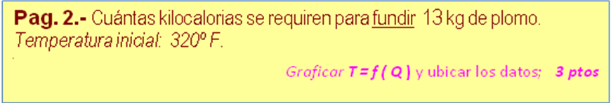
c _{PLOMO} = | 0,0310 | cal /gr-ºC
L_{f PLOMO} = | 6,30 | cal /gr
L_{V PLOMO} = | 222,00 | cal /gr
Punto de fusión = | 620 | ºF
Punto de vaporización = | 3171 | ºF

m | 13 | kg | 13.000,0000 | gr
Tf | 620 | ºF | 326,6667 | ºC
T₁ | 320 | ºF | 160,0000 | ºC
 | Δ_{Q} = m *(c_{PLOMO *}(Tf -T₁) +Lf _{PLOMO} )/1000
 |  | Δ _{Q} | 149,0667 | kcal

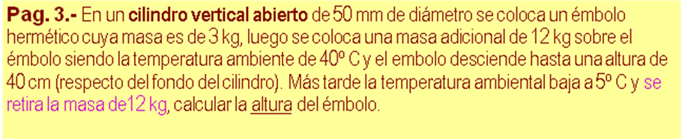
P_{ATM} = | 101325 | Pa
ρ _{AIRE =} | 1,29 | kg /m³

Diám. | 0,05 | m | 0,0020 | m² (A)
m_{EMB} | 3,0 | kg | 29,4000 | N (W_{EMB})
m_{ADIC} | 12,0 | kg | 117,6000 | N (W_{ADIC})
h₁ | 0,40 | m | 0,0008 | m³ (Vol)
T₁ | 40,0 | ºC | 313,00 | ºK
T₂ | 5,0 | ºC | 278,0000 | ºK
 |  | P₁ | 176.191,4852 | Pa
 |  | P₂ | 116.298,2970 | Pa
 | h₂ = h₁*P₁*T₂ /(T₁*P₂)*100
 |  | h₂ | 53,8235 | cm

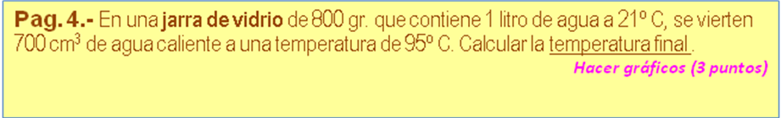
VIDRIO
c _{VIDRIO =} | 0,1600 | cal /gr-ºC
ρ _{VIDRIO =.} | 2,6000 | gr /cm³
AGUA FRIA
c _{AGUA F. =} | 1,0000 | cal /gr-ºC
ρ _{AGUA F =} | 1,0000 | gr /cm³
AGUA C.
c _{AGUA C. =} | 1,0000 | cal /gr-ºC
ρ _{AGUA C. =} | 1,0000 | gr /cm³
P.ebullición _{AGUA =.} | 100,00 | ºC

m_{VIDRIO} | 800,0 | gr
v_{AGUA} | 1,0 | Lt | 1.000,0000 | gr
T₁ | 21,0 | ºC
Vol_{AGUA C.} | 700,0 | cm³ | 700,0000 | gr
T₂ | 95,0 | ºC
T₃ ₌ (T₁*(m_{VIDRIO} *c_{VIDRIO} +m_{AGUA F}*c_{AGUA F} ) +m_{AGUA C.} *c_{AGUA C.} *T₂)/
 | (m_{VIDRIO} *c_{VIDRIO} +m_{AGUA F}*c_{AGUA F} +m_{AGUA C.} *c_{AGUA C.} )
 |  | T₃ | 49,3370 | ºC

