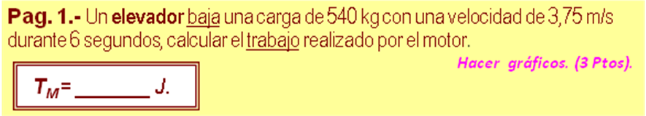

m | 540 | kg | 5000,0000 | w (N)
v₁ | 3,75 | m/s | 3796,8750 | J (Ec₁)
v₂ | 3,75 | m/s | 3796,8750 | J (Ec₂)
t | 6 | s
 |  |  | 0,0000 | m/s² (a)
 |  |  | 22,5000 | m (h)
 |  |  | 119070,0000 | J (Eg₁)
 |  | T = (E_{C2} -(E_{PG1}+E_{C1 )})
 |  | T | -119070,0000 | J

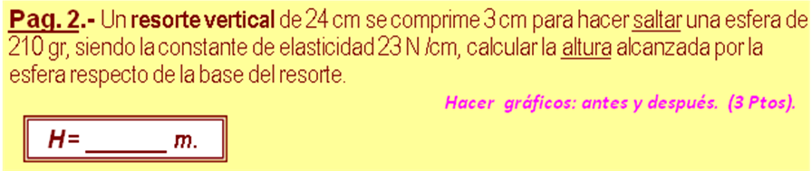

m | 210 | gr | 0,2100 | kg
Lo | 24 | cm | 0,2400 | m
y | 3 | cm | 0,0300 | m
k | 23 | N /cm | 2300,0000 | N/m
 |  | h = k*y^2/(2 *m *g)
 |  | h | 0,5029 | m
 |  | H= h +Lo -y
 |  | H | 0,7129 | m

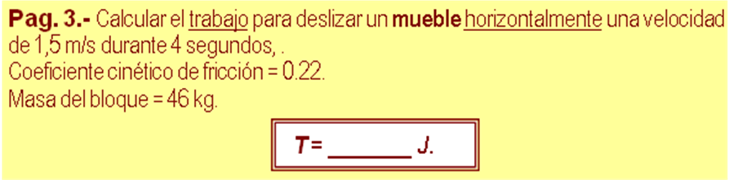

m | 46 | kg | 450,8000 | N (w)
v₁ | 1,5 | m /s
v₂ | 1,5 | m /s
t | 4 | s | 0,0000 | m/s² (a)
μ | 0,22
y | 0 | 100 | 6,0000 | m (d)
x | 100 |  | 0,0000 | m (h)
 | T= m *d *(g *senα +μ *g *cosα +a)
 |  | T | 595,0560 | J

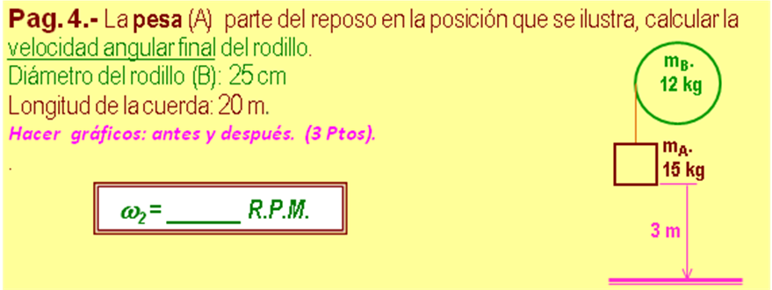

m_{A} | 15 | kg
m_{B} | 12 | kg | 0,0938 | kg-m2 (I)
h | 3 | m
D | 0,25 | m | 0,1250 | m (R)
 | v₂ = ( 2 ,m_{A} .g .h / ( m_{A} + m_{B} /2 ))^0,5
 |  | v₂ | 6,4807 | m/s
 | ω₂ = (v₂ /R )*(60/(2*pi()))
 |  | ω₂ | 495,0921 | r.p.m.

