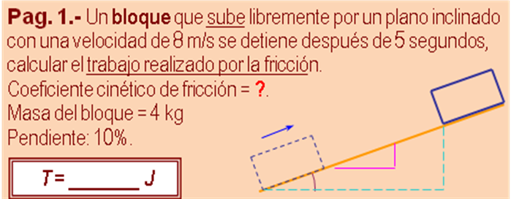

*Solución:*

|  |  |  |  |  |
| --- | --- | --- | --- | --- |
| m | **4** | kg |  |  |
| v1 | **8** | m /s |  |  |
| v2 | **0** | m /s |  |  |
| t | **5** | s |  |  |
|  |  |  | -1,6000 | m/s2 (a) |
| **y** | **10** | 100,5 | 20,0000 | m (d) |
| **x** | **100** |  | 1,9901 | m (h) |
|  | T= m *( g *h - v1^2 /2 ) | | |  |
|  |  | **T*f*** | **-49,9891** | **J** |

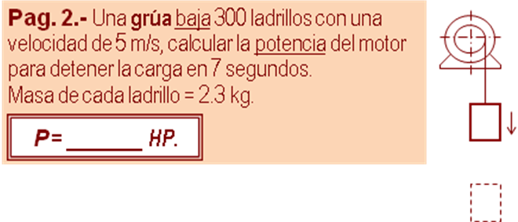

*Solución:*

|  |  |  |  |  |
| --- | --- | --- | --- | --- |
| m | **690** | kg |  |  |
| v1 | **5** | m /s |  |  |
| v2 | **0** | m /s |  |  |
| t | **7** | s |  |  |
|  |  |  | -0,7143 | m/s2 (a) |
| **y** | **100** | 100 | 17,5000 | m (d) |
| **x** | **0** |  |  |  |
|  | P= (m *( v1^2 /2 + g *h)) / t /746 | | |  |
|  |  | **P** | **24,3125** | **HP** |

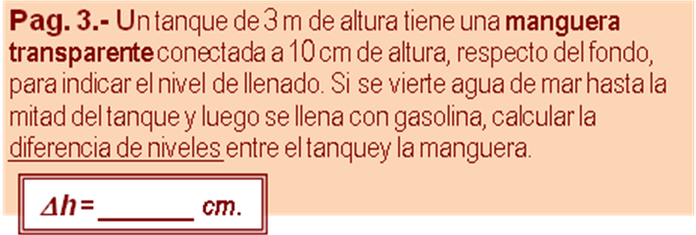

*Solución:*

|  |  |  |  |  |
| --- | --- | --- | --- | --- |
| H | **150** | cm |  |  |
|  |  | h = H *( 1-  Gasolina /  A.mar) | | |
|  |  | **h** | **50,9709** | **cm** |

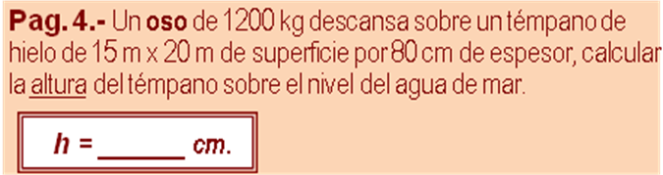

|  |  |  |
| --- | --- | --- |
| **** HIELO = | **920** | kg /m3 |
| **** A.mar = | **1030** | kg /m3 |
| **P**ATM = | **101325** | Pa |

*Solución:*

|  |  |  |  |  |
| --- | --- | --- | --- | --- |
| m O | **1.200** | kg | 11.760,00 | N (w F) |
| a H | **15** | m2 |  |  |
| b H | **20** | m2 | 240,00 | m3 (vol H) |
| e H | **0,80** | m | 2.163.840,00 | N (w H) |
|  |  | y = (xF +wH)/(A.mar .A .g) | |  |
|  |  | **y** | **0,7184** | **m** |
|  |  | h = (eH -y)*100 | |  |
|  |  | **h** | **8,1553** | **cm** |