http://www.icm.espol.edu.ec/main/images/titulo2.JPG **ESCUELA SUPERIOR POLITÉCNICA DEL LITORAL**

**INGENIERÍA EN LOGÍSTICA Y TRANSPORTE**

**EXAMEN FINAL – LOGÍSTICA EN REVERSA ENERO – 2012**

**Nombre: _____________________________ Matrícula No.: ____________**

**Profesor: Ing. Víctor Vega Chica**

**PARTE A: BASE TEÓRICA**

**(5 PUNTOS) 1.- Según su criterio que es Logística Verde?**

**________________________________________________________________________________**

**________________________________________________________________________________**

**________________________________________________________________________________**

**________________________________________________________________________________**

**________________________________________________________________________________**

**________________________________________________________________________________**

**(5 PUNTOS) 2.- Mencione cuáles son los 4 pasos de la metodología basados en reconocimiento de emisiones de carbono estandares.?**

**________________________________________________________________________________**

**________________________________________________________________________________**

**________________________________________________________________________________**

**________________________________________________________________________________**

**________________________________________________________________________________**

**________________________________________________________________________________**

**PARTE B: SECUENCIACIÓN DE DESENSAMBLAJE**

**(25 PUNTOS)** Deseamos extraer de un ordenador de sobremesa las tarjetas (los controladores de discos, la tarjeta gráfica, la memoria y el controlador de entrada y salida, así como de la disquetera y disco duro sus respectivos controladores:

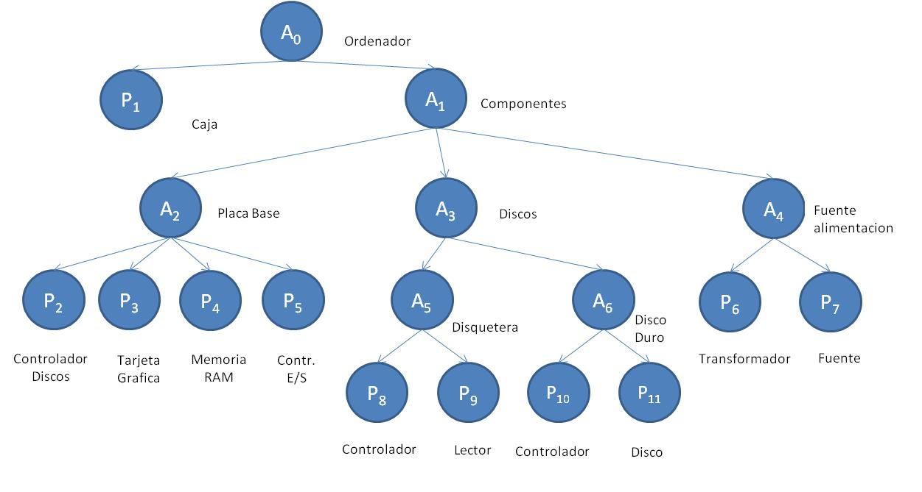

|  |  |  |  |  |  |  |  |  |  |  |  |  |
| --- | --- | --- | --- | --- | --- | --- | --- | --- | --- | --- | --- | --- |
|  | **A0** | **A1** | **A2** | **A3** | **A5** | **A6** | **P2** | **P3** | **P4** | **P5** | **P8** | **P10** |
| **Tiempo desensamblaje, tD** | 1 | 1 | 2 | 5 | 3 | 6 |  |  |  |  |  |  |
| **Tiempo extracción, tE** |  |  |  |  |  |  | 2 | 3 | 3 | 5 | 2 | 4 |

Diseñar un diagrama de Gantt donde refleje el tiempo de desensamblaje.

**PARTE C: MRP INVERSO**

**(25 PUNTOS)** Establecer el MRP para la familia H-I-F

**Estructura del desensamblaje correspondiente al producto A**

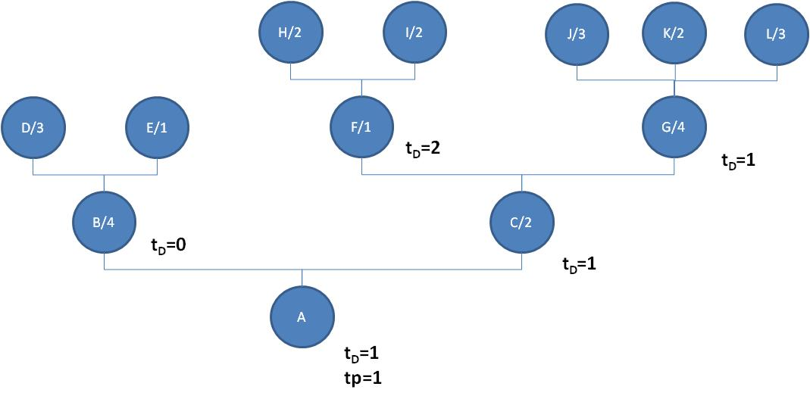

Plan Maestro establecido para los componentes finales:

|  |  |  |  |  |  |  |  |  |  |  |
| --- | --- | --- | --- | --- | --- | --- | --- | --- | --- | --- |
|  | **1** | **2** | **3** | **4** | **5** | **6** | **7** | **8** | **9** | **10** |
| **D** |  |  | 35 |  | 55 |  | 45 | 20 |  | 188 |
| **E** |  |  |  |  | 15 | 65 |  | 36 | 120 | 44 |
| **H** |  |  |  |  | 25 |  | 31 | 44 | 96 | 320 |
| **I** |  |  |  |  | 35 | 15 |  | 66 | 44 | 96 |
| **J** |  |  | 65 |  | 35 | 50 | 180 | 720 | 264 | 576 |
| **K** |  |  | 50 |  | 55 | 70 |  | 110 | 480 | 176 |
| **L** |  |  |  |  | 80 | 65 |  | 220 | 720 | 264 |

Pedidos pendientes externos y existencias actuales:

|  |  |  |  |  |  |  |  |  |  |  |  |
| --- | --- | --- | --- | --- | --- | --- | --- | --- | --- | --- | --- |
|  | **EXD0** | **1** | **2** | **3** | **4** | **5** | **6** | **7** | **8** | **9** | **10** |
| **A** | 1 |  |  |  |  |  |  | 9 |  | 2 |  |
| **B** | 2 | 2 | 4 | 8 |  |  |  | 6 |  | 2 |  |
| **C** | 6 | 5 | 7 | 1 | 9 |  |  |  |  |  |  |
| **D** | 10 |  | 15 |  |  | 2 | 4 |  |  |  |  |
| **E** | 30 |  | 8 |  |  |  |  |  |  |  |  |
| **F** | 45 |  |  | 15 | 2 | 4 | 8 |  |  |  |  |
| **G** | 12 | 1 | 9 |  | 2 | 3 |  |  |  |  |  |
| **H** | 55 | 1 | 6 |  | 2 | 1 | 2 |  |  |  |  |
| **I** | 20 | 7 | 1 | 9 |  |  |  | 7 | 2 | 8 |  |
| **J** | 120 | 3 | 15 | 2 | 4 | 8 |  |  | 2 | 5 | 1 |
| **K** | 90 |  |  | 5 | 7 | 1 | 9 |  | 2 | 3 |  |
| **L** | 80 | 4 | 7 | 2 | 8 | 1 | 6 |  | 2 | 1 | 2 |