 | ESCUELA SUPERIOR POLITECNICA DEL LITORAL  Centro de Lenguas Extranjeras  CELEX – ESPOL  Intermediate B  Midterm V3 EU | 
- Reading Section (15 marks)

Read the text and do the activities

'Sesame Street' Movie in the Works From FOX


20th Century FOX wants to tell you how to get to Sesame Street. The studio has picked up the movie rights to the long-running and iconic children's television show and has tapped longtime "Sesame Street" writer Joey Mazzarino to write the script. Producers are Shawn Levy and his 21 Laps banner, Michael Aguilar, Mark Gordon and Film 360's Guymon Casady.
The educational series, which premiered in 1969, airs mostly on PBS stations and features a combination of live-action and puppetry, as well as animation. It is best known as the home of the Jim Henson creations Big Bird, Bert and Ernie, Grover, Oscar the Grouch, Cookie Monster and Elmo. It's estimated that about one in three Americans has watched the show, and the format is broadcast in dozens of countries. "Sesame Street" also has won 138 Emmys during its run.
The series has generated two previous big-screen adaptations, 1985's "Follow That Bird" and 1999's "The Adventures of Elmo in Grouchland." It was distributed by Warner Bros.
Sesame Workshop, the company behind the show (and formerly known as Children's Television Workshop), likely will be involved in a producer capacity as well.
FOX had no comment on the news.
Levy, the director of "Night at the Museum," "Date Night" and "Real Steel," is eyeing a July start for his next movie, the FOX comedy "The Internship," which will reteam "Wedding Crashers" stars Vince Vaughn and Owen Wilson. 21 Laps is producing the coming-of-age indie "The Spectacular Now" and the FOX 2000 Christmas comedy "Alone for the Holidays."

Answer the questions. (7 marks)

- Who has movie rights to Sesame Street?
- Who is going to write the script?
- When was the show first on TV?
- Which award has the series been given?
- Is this the first time the series will be adapted into a movie?
- Will FOX be the only one involved in producing the film?
- In which movie did Vince Vaughn and Owen Wilson work together before?

6 Big Fat Pregnancy Myths
There is more superstition surrounding pregnancy than any other so-called "medical condition." To separate fact from fiction, we examined the science behind the hearsay.

- _________________________________
Time to break it to grandma: Basketball-shaped bellies do not forecast boys. In a study of 104 women, published in the journal Birth in 1999, no correlations were found between a pregnant belly's size or shape and the baby's gender.
Similarly, predictions using the Chinese lunar calendar, the fetal heart rate and the Drano test were examined by physicians in Vancouver in 1999. None of them were reliable.

- _________________________________
Fraternal twins do run in families, due to a gene that can make a woman more likely to release multiple eggs during ovulation. But the hyper-ovulation gene doesn't leap over certain generations. It is passed on from parent to child just like all genes are. Evidence shows that identical twins, however, occur at random, rather than running in families. If there are many sets of carbon-copies in your family line, "it is probably just a coincidence," Dr. Vreeman said.

- __________________________________
She's not alone: Dad's dealing with hormone shifts, too.
A study published in the journal Evolution and Human Behavior in 2000 found that over the course of his mate's pregnancy, an expectant father's testosterone levels go down and his prolactin levels go up.

- __________________________________
"With exercise and diet, it certainly is possible to get back in the shape you were in before getting pregnant," Stone said, adding that this is easiest for people who were quite fit before conceiving.
People tend to forget that the body changes with age, with or without a pregnancy, Stone told MyHealthNewsDaily. So before blaming your extra pounds on your offspring, try counting the candles on your next birthday cake.

- _____________________________________

While infants certainly drain a lactating breast, their hunger doesn't cause long-term changes in breast firmness. Scientists have confirmed breastfeeding does not contribute to breast ptosis (the scientific name for saggy breasts).
However, multiple pregnancies, smoking and simply getting older have been correlated with droopier cleavage, according to a study of 132 women published in the Annals of Plastic Surgery in May.

- ________________________________
This may be true in the first few months, when a 30-fold increase in progesterone makes most women really, really, sleepy.
But pregnancy brain may not be all bad. In a small pilot study of 10 women, Stone and colleagues found that women tend to have increased attention spans in their third trimester. If the results are confirmed in a larger group of women — something the researchers are currently working on — it may be an indicator of "neuronal nesting." "This may be nature's way of increasing the attention a mother is going to need to give a newborn," Stone said.

*sag: to drop down
Adapted from msn.com

Match the headings 6 - 10 to the paragraphs a - f. (3 marks)

- Your body will never be the same again.
- You can predict the sex of your baby
- The mom-to-be is the only one going through hormonal changes.
- Twins skip a generation.
- Breastfeeding makes your breasts sag.
- "Pregnancy brain" makes it impossible to concentrate.

Write true or false next to each sentence. (5 marks)

- Some people think they can predict the baby`s sex by looking at the mother`s belly.
- Having twins is decided by genetics.
- Men`s hormones change when their partners are pregnant.
- Women who have been pregnant will never look good again.
- Breastfeeding leaves women`s breasts in perfect conditions.

- Use of English (20 marks)

You are at the jewelry store, write directions to get to the following places. (5 marks)

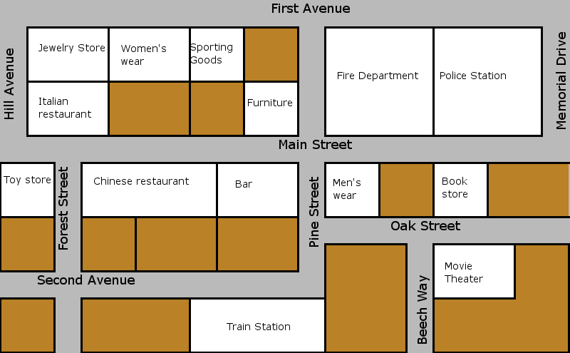

- The movie theater
- The police station
- The bar
- The train station
- The toy store

Fill in the gaps with the correct from of the verbs in parenthesis. (5 marks)

- In Ecuador children ___________________(teach) English at school.
- Nowadays most families ___________________(eat) pre- cooked meals.
- Snacks and lunches ___________________(provide) by schools nowadays.
- Mothers ___________________(make) their children breakfast in the past.
- Movies ___________________(not have) as many special effects in the past.

Make predictions about the following things in the year 2050. Use will, might, may. (5 marks)

- Children
- Free time
- Shopping
- Exercising
- Learning foreign languages

Choose one word from the box to complete the sentences (5 marks)

Starving exhausted furious freezing positive

- When he told me I had to do the whole project again I was ____________ because he never suggested
any changes in the process.
- I’m sorry I didn’t wait for you at dinner, but I was ____________.
- I packed in such a hurry that I forgot my sweater and it was 10C I was ____________.
- After work the girls and I went dancing. I came home at 5.00 I was ____________.
- I’m ____________ I left my purse in the taxi. I paid the drive and when I wanted to pay the restaurant
bill I didn’t have it with me.
- Listening Section (15 marks)
Listen and write true or false

- Tristan always works 8 hours a day.
- He has to be on call 4 nights a week.
- He sometimes works unsocial hours.
- He works in the same place all day.
- After a nightshift he can go home.
- It’s difficult for him to sleep after an emergency
- He studied at London University.
- He had to look for a job after he graduated.
- His school partners don’t have good jobs.
- His pay is not good.
- He wants to have his own practice in the future.
- He’s a pediatrician.
- Pets are usually not important to people
- After an emergency he has to be sensitive with his clients.
- Sheep usually don’t have many babies at once.
- Writing Section (15 marks)
Question one:
Write about the area where you live. What are the pros and cons of living there? Give as much detail as possible. Give reasons why you think that about this place. Write 100 words. (7.5 marks)

Question two:
Think about a time you felt delighted / furious / amazed. Write about your experience. Write 100 words. (7.5 marks)

