 | ESCUELA SUPERIOR POLITECNICA DEL LITORAL  Centro de Lenguas Extranjeras  CELEX – ESPOL  Intermediate B  Midterm V2 EU | 
- Reading Section (15 marks)

Read the text and do the activities

Adele song 'Rolling in the Deep' wakes British girl from coma
By Gael Fashingbauer Cooper
Singer Adele's hit song, "Rolling in the Deep," is credited with helping a 7-year-old British girl wake from the coma she suffered after a brain hemorrhage.

Charlotte Neve suffered the hemorrhage April 11 during a normal night of watching DVDs with her family, and mother Leila told the U.K. Telegraph that the situation became so grave that "doctors told me to say goodbye."
But when "Rolling in the Deep," a song mother and daughter often sang, came on the radio, Leila Neve started singing it to her daughter and the little girl started to smile.
"It was the first time she had reacted to anything since the hemorrhage," Leila Neve told the newspaper. "The nurses were astounded and told me to keep singing, and she smiled again. The nurses said it was like I 'unlocked her' and from that day she started getting better and better."
Charlotte Neve is now recovering at home, but still suffers from partial blindness and memory loss, the Telegraph reports. The family has set up a Facebook page for donations.
Also in April, Bee Gees founding member Robin Gibb awoke from a coma after his family sang and played music to him. He reportedly awoke while music from his latest composition, the classical "Titanic Requiem," was playing. Gibb died May 20 from liver and kidney failure.
Taken from msn.com

Answer the questions. (5 marks)

- Where is Charlotte from?
- What was she doing when she had the hemorrhage?
- Did Leila hope her daughter would get better?
- What problems does Charlotte still have?
- Is Charlotte`s the only case of people waking from comas with music?
Match the underlined words in the text to their synonyms below. (2 marks)

- Getting better
- Serious
- Is attributed
- Surprised

6 Big Fat Pregnancy Myths
There is more superstition surrounding pregnancy than any other so-called "medical condition." To separate fact from fiction, we examined the science behind the hearsay.

a.________________________
"It's actually more like nine-and-a-half months," said Dr. Joanne Stone, an obstetrician at Mount Sinai School of Medicine.
To make matters more confusing, doctors typically measure pregnancy's length as 40 weeks, counting from a woman's last period.

b. _________________________
Dads-to-be have two types of sperm: those that make baby boys and those that make baby girls. Some say that the body of a mom-to-be is more hospitable to boy sperm or girl sperm during certain times in her cycle. And so, the theories go, when a couple has sex can determine whether they conceive a Junior or a Bubette.
While a few small studies have supported timing methods for sex selection, larger, more recent studies have failed to find any correlation between the day within the fertile window a couple has sex and the gender of the baby.
The only way you can reliably choose the sex of your baby is with the help of technology.

c._________________________________
Fraternal twins do run in families, due to a gene that can make a woman more likely to release multiple eggs during ovulation. But the hyper-ovulation gene doesn't leap over certain generations. It is passed on from parent to child just like all genes are.
Evidence shows that identical twins, however, occur at random, rather than running in families. If there are many sets of carbon-copies in your family line, "it is probably just a coincidence," Dr. Vreeman told MyHealthNewsDaily.

d._________________________________
While most women experience some swelling in their calves, ankles and feet during pregnancy, many can fit back into their favorite heels at some point postpartum.
But this one isn't a complete myth: Some women permanently go up a half-size over the course of a pregnancy – and possibly even another half-size with each subsequent pregnancy. "Hopefully, they're not having ten kids," Stone laughed.

e. _________________________________
While excessive drinking during pregnancy can cause severe problems, recent studies of thousands of women in the United Kingdom and Australia have confirmed earlier research suggesting that light to moderate drinking – usually defined as one drink a week to one small drink most days – may not be harmful.
Drinking during pregnancy is more culturally acceptable in Europe and Australia, than in the United States. But many physicians in the United States, such as Dr. Michael Broder, author of "Panic-Free Pregnancy", also quietly allow their patients to have the occasional alcoholic drink – particularly after the first trimester.

f. _________________________________
If only this were true! Thought to be caused by shifting hormones, morning sickness can strike (and often does) at any point in the day. And it's not confined to the first trimester, as many believe, Stone said. "It can last up to 16 weeks."
Match the headings 10 - 15 to the paragraphs a - f. (3 marks)

- Twins skip a generation.
- Drinking any alcohol during pregnancy will hurt your baby.
- Pregnancy lasts nine months.
- "Morning" sickness only happens in the morning.
- Pregnancy makes your feet grow.
- When you have sex determines the gender of your baby.

Write true or false next to each sentence. (5 marks)

- The way doctors measure pregnancy is easier to understand than any other way.
- People can choose their baby`s sex with or without technology`s help.
- Some women`s feet stay bigger after pregnancy.
- Drinking during pregnancy is more accepted in some places than in others.
- Morning sickness only happens during the first trimester of the pregnancy.
- Use of English (20 marks)
You are at the fire department, write directions to get to the following places. (5 marks)

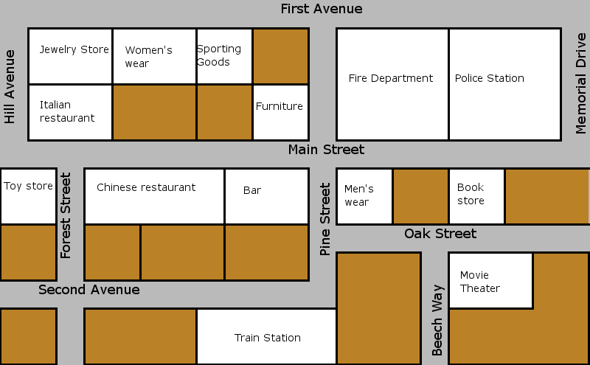

21. The movie theater
22. The Italian Restaurant
- The bar
- The train station
- The toy store

Make predictions about the following things in the year 2050. Use will, might, may. (5 marks)

- Traffic
- Food
- Education
- Transportation
- Families

Fill in the gaps with the correct from of the verbs in parenthesis. (5 marks)

- Babies ___________________(feed) by their mothers or caretakers.
- Children usually ___________________(learn) one foreign language at school.
- In the past shoes ___________________(make) by hand.
- In 2008 a law ___________________(pass) that allows students to attend University for free.
- Dogs ___________________(teach) tricks in order to impress people.
Choose one word from the box to complete the sentences. (5 marks)
Charge check – out reservation book included

- In most five stars hotels breakfast is ________________.
- Before people ________________ hotel staff go over their bills.
- You have 6 hours internet access during your stay, if you want more time the hotel ______________ you extra for that.
- Guests ________________ rooms a month in advance in the Hilton Colon.
- If you want to make a ________________ you have to call first and check availability.

- Listening Section (15 marks)

Listen and complete.

- Tristan usually works 8 - ___________ hours a day.
- He has to be on call ___________ nights a week.
- He usually works unsocial hours because he never knows if there’ll be an ___________.
- In the ___________ he works in the surgery.
- He goes to ___________ in the countryside.
- The nightshift is the most ___________ thing about the job.
- After an emergency he finds it difficult to ___________.
- He studied for ___________ years.
- When he graduated he didn’t have to look for a ___________
- Most of his friends have ___________ jobs now.
- When he has his own ___________ his pay will be better.
- He works with ___________.
- He says that ___________ are important to people.
- He helped a sheep have ___________ babies recently.
- He plans to start his own ___________.

- Writing Section (15 marks)
Question one:
Write a posting about a place you know well. Mention the following information: places and buildings, events, the weather, things to do there. Write 100 words. (7.5 marks)

Question two:
Your best friend from school contacted you in Facebook. Reply his/ her e-mail. Write 100 words. (7.5 marks)
Your best friend wrote:
Hi,
How are you? I haven’t heard from you in a long time. What have you been up to?
Tell me about all the things you’ve done since we graduated.
Love,
XXXX

