EXAMEN DEL III PARCIAL DE GEOLOGÍA ESTRUCTURAL Y DEL PETRÓLEO
II TERMINO 2012 – 2013

NOMBRE: _______________________________________________________________
DOCENTE: ING. KENNY ESCOBAR SEGOVIA

- HABLE DETALLADAMENTE SOBRE EL POTENCIAL HIDROCARBURIFERO DEL ECUADOR (50 PUNTOS):

________________________________________________________________________________________________________________________________________________________________________________________________________________________
_______________________________________________________________________________________________________________________________________________________________________________________________________________________
________________________________________________________________________________________________________________________________________________________________________________________________________________________
________________________________________________________________________________________________________________________________________________________________________________________________________________________
________________________________________________________________________________________________________________________________________________________________________________________________________________________
________________________________________________________________________________________________________________________________________________________________________________________________________________________
________________________________________________________________________________________________________________________________________________________________________________________________________________________
________________________________________________________________________________________________________________________________________________________________________________________________________________________
________________________________________________________________________________________________________________________________________________________________________________________________________________________
________________________________________________________________________________________________________________________________________________________________________________________________________________________
________________________________________________________________________________________________________________________________________________________________________________________________________________________
________________________________________________________________________________________________________________________________________________________________________________________________________________________

- EJERCICIO (36 PUNTOS):

En ABC aflora un estrato de caliza.
- Hallar el rumbo y buzamiento de la caliza (12 puntos).
- Realice un diseño de afloramiento con el rumbo obtenido (12 puntos).
- Calcule el buzamiento aparente en las siguientes direcciones N45E y N110E (12 puntos)
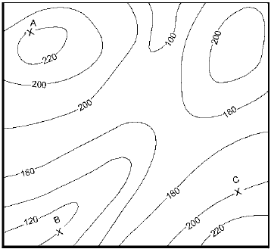

Trabaja con escala 1:100

