PROFESOR: ING. KENNY ESCOBAR SEGOVIA
NOMBRE: _______________________________________________________________

- ¿A que se denominan depósitos tipo Skarn y que minerales podemos encontrar en estos depósitos? (7 puntos)
______________________________________________________________________________________________________________________________________________________________________________________________________________________________________________________________________________________________________________________________________________________________________________________________________________________________
- La formación de depósitos tipo Skarn involucra esencialmente tres etapas ¿Cuáles son? (6 puntos)
_______________________________________________________________________________________________________________________________________________________________________________________________________________
- ¿Para que estudiamos las alteraciones hidrotermales? (2 puntos)
__________________________________________________________________________________________________________________________________________

- Explique lo que quiere explicar la siguiente imagen (7 puntos):
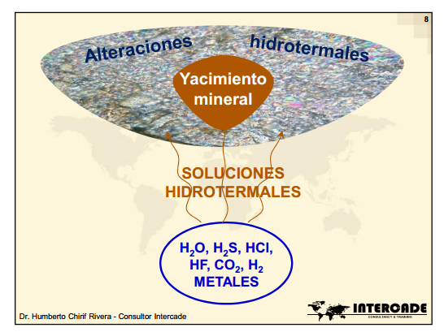
__________________________________________________________________________________________________________________________________________________________________________________________________________________________________________________________________________________________________________________________________________________________________________________________________________________________________________________________________________________________________________________________________________________________________________________________________________________________________________________

- Detalle los cuatro pasos para que se forme un yacimiento a partir de alteraciones hidrotermales (8 puntos):
- __________________________________________________________________________________________________________________________________________________________________________________________
- __________________________________________________________________________________________________________________________________________________________________________________________
- __________________________________________________________________________________________________________________________________________________________________________________________
- __________________________________________________________________________________________________________________________________________________________________________________________

- Según la lectura de los Yacimientos Sedimentarios, haga un breve resumen (15 puntos)
______________________________________________________________________________________________________________________________________________________________________________________________________________________________________________________________________________________________________________________________________________________________________________________________________________________________________________________________________________________________________________________________________________________________________________________________________________________________________________________________________________________________________________________________________________________________________________________________________________________________________________________________________________________________________________________________________________________________________________________________________________________________________________________________________________________________________________________________________________________________________________________________________________________________________________________________________________________________________________________________________________________________________________________________________________________________________________________________________________________

