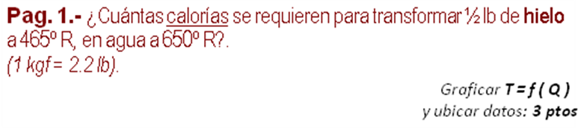
ρ _{HIELO =} | 0,92 | gr /cm³
ρ _{AGUA =} | 1,00 | gr /cm³
L_{f HIELO =} | 80,00 | cal /gr
L_{v AGUA =} | 540,00 | cal /gr
c _{HIELO =} | 0,50 | cal /gr-ºC
c _{AGUA =} | 1,00 | cal /gr-ºC
c _{VAPOR =} | 0,48 | cal /gr-ºC
Punto de fusión = | 0 | ºC
Punto de vaporización = | 100 | ºC

t ₂ | 650,0 | ºR | 87,8 | ºC
t _{f} | 492,0 | ºR | 0,0 | ºC
t ₁ | 465,0 | ºR | -15,0 | ºC
w | 0,50 | lb | 227,3 | grf
Δ_{Q} = (c_{HIELO}*(Tf -T1) +Lf _{HIELO} +c_{AGUA}*(t2-Tf))*m
 |  | Δ _{Q} | 39.835,86 | cal

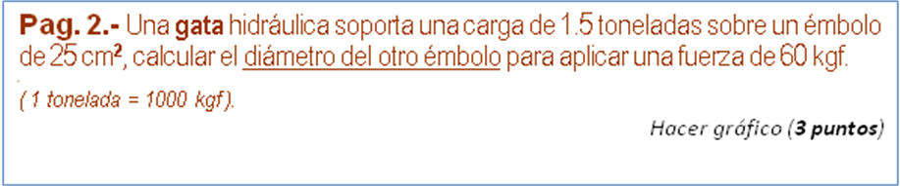

w | 1,5 | Ton | 1500,0000 | kgf
F | 60 | kgf
A₁ | 25 | cm2 | 5,6419 | cm (D1)
 | diám = (( F/w )^0,5)*D1
 |  | diám | 1,1284 | cm

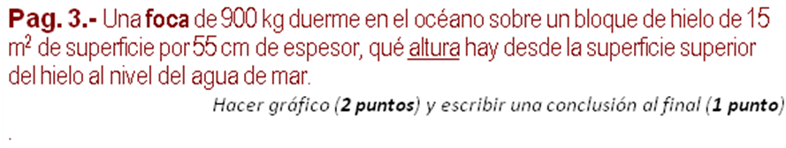
ρ _{HIELO =} | 920 | kg /m³
ρ _{AGUA =} | 1000 | kg /m³
ρ _{A.mar =} | 1031 | kg /m³

m _{F} | 900 | kg | 8.820,00 | N (w _{F})
A _{H} | 15 | m² | 8,25 | m³ (vol _{H})
e _{H} | 0,55 | m | 74.382,00 | N (w _{H})
 |  | y = (x_{F} +w_{H})/(ρ_{A.mar} .A .g)
 |  | y | 0,5490 | m
 |  | h = (e_{H} -y)*100
 |  | h | 0,1018 | cm

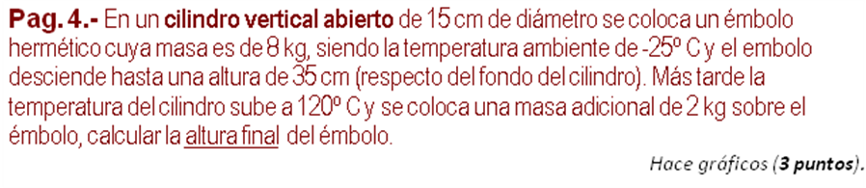
P_{ATM} = | 101325 | Pa

Diám. | 0,15 | m | 0,0177 | m² (A)
m_{EMB} | 8,0 | kg | 78,4000 | N (W_{EMB})
m_{ADIC} | 2,0 | kg | 19,6000 | N (W_{ADIC})
h₁ | 0,35 | m | 0,0062 | m³ (Vol)
T₁ | -25,0 | ºC | 248,00 | ºK
T₂ | 120,0 | ºC | 393,00 | ºK
 |  | P₁ | 105.761,5325 | Pa
 |  | P₂ | 106.870,6656 | Pa
 | h₂ = h₁*P₁*T₂ /(T₁*P₂)*100
 |  | h₂ | 54,8881 | cm

